BEACONHOUSE NATIONAL UNIVERSITY


LAB 5 | WEEK 5

Name: Saad Mughal
BNU ID: F2023-009

Due Date: 20 Mar, 2025

Lab Manual
For
ADMS(SEC_B)
Course Instructor | Ms. Talia Noreen
Lab Instructor | Mr. Ahsan Atiq
Semester | Spring 2025

1. Find customers from New York who placed orders in the East region.
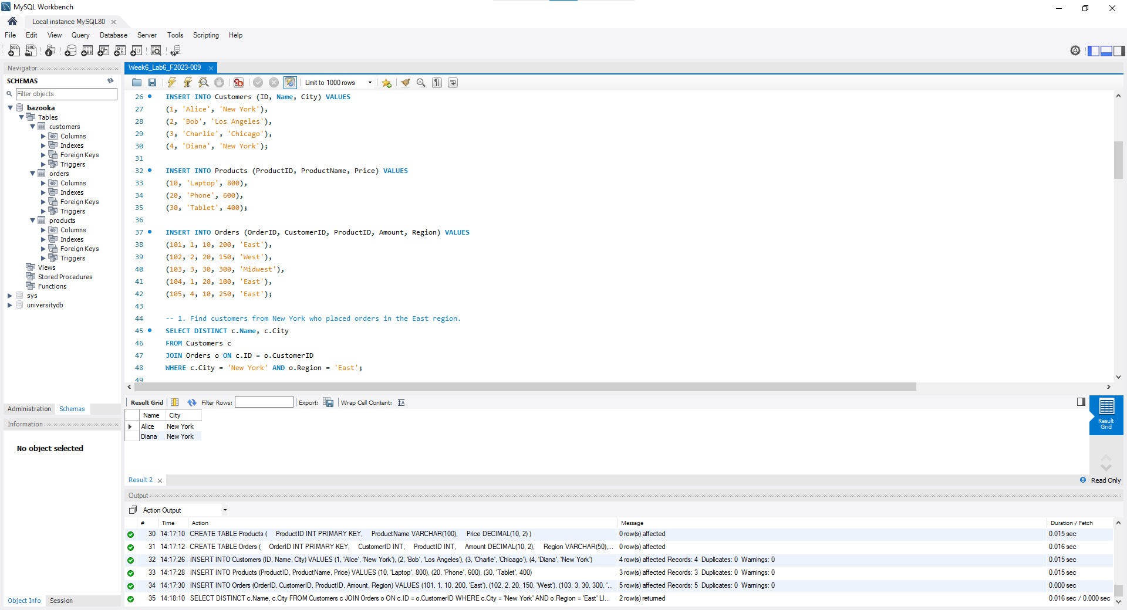
2. Find products with a price greater than ANY product ordered by CustomerID.
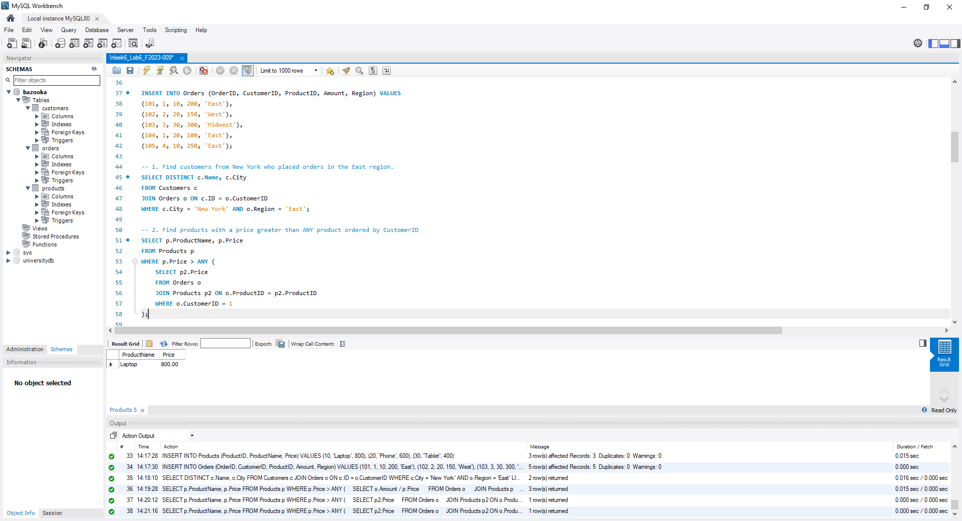

3. Find products priced higher than ALL products in the Phone category (assume Phone has ProductID 20).
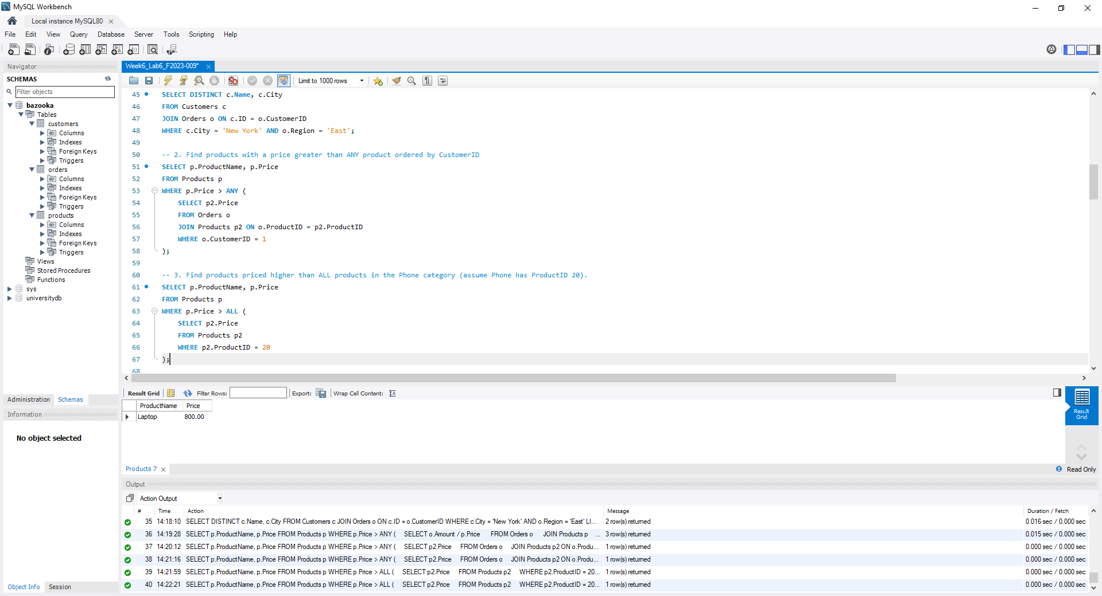
4. Find customers who have placed at least one order in the East region.
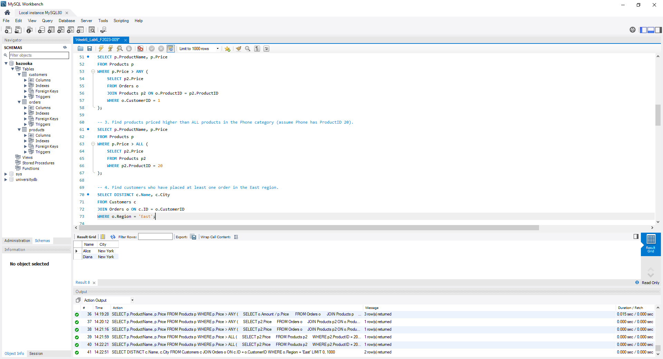

5. Find products ordered by customers from New York.
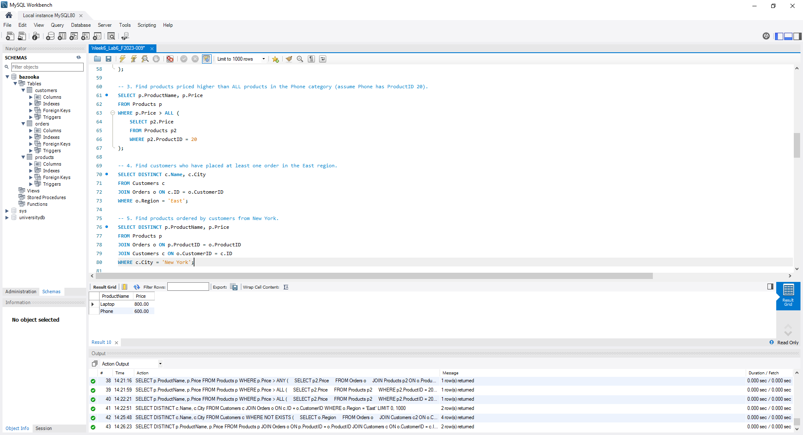
6. Find customers (Name, City) who placed orders in the East region and are from New York.
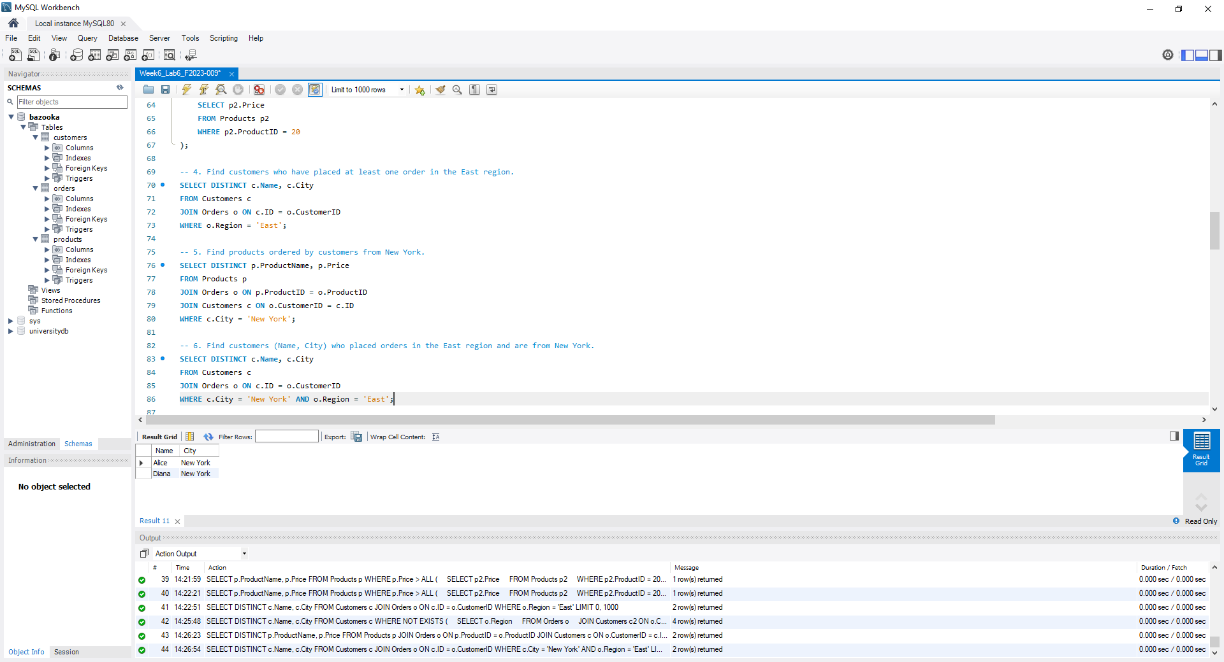

7. List products (ProductName, Price) priced higher than ANY product ordered by CustomerID 1 (Alice).
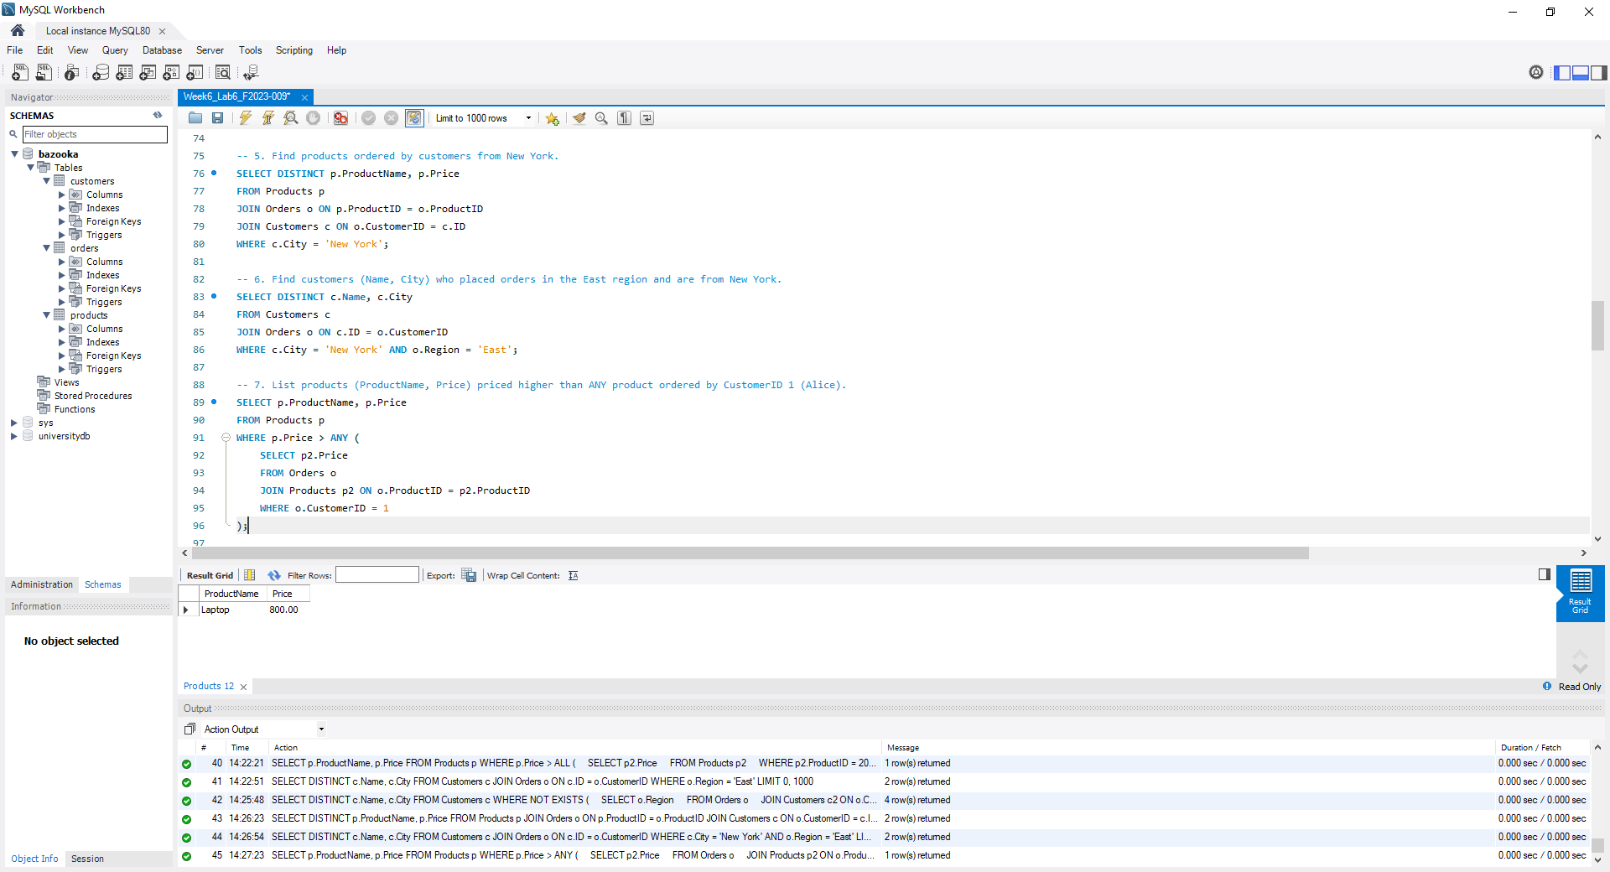
8. Find customers (Name, City) whose total order amount exceeds ALL individual orders in the West region.
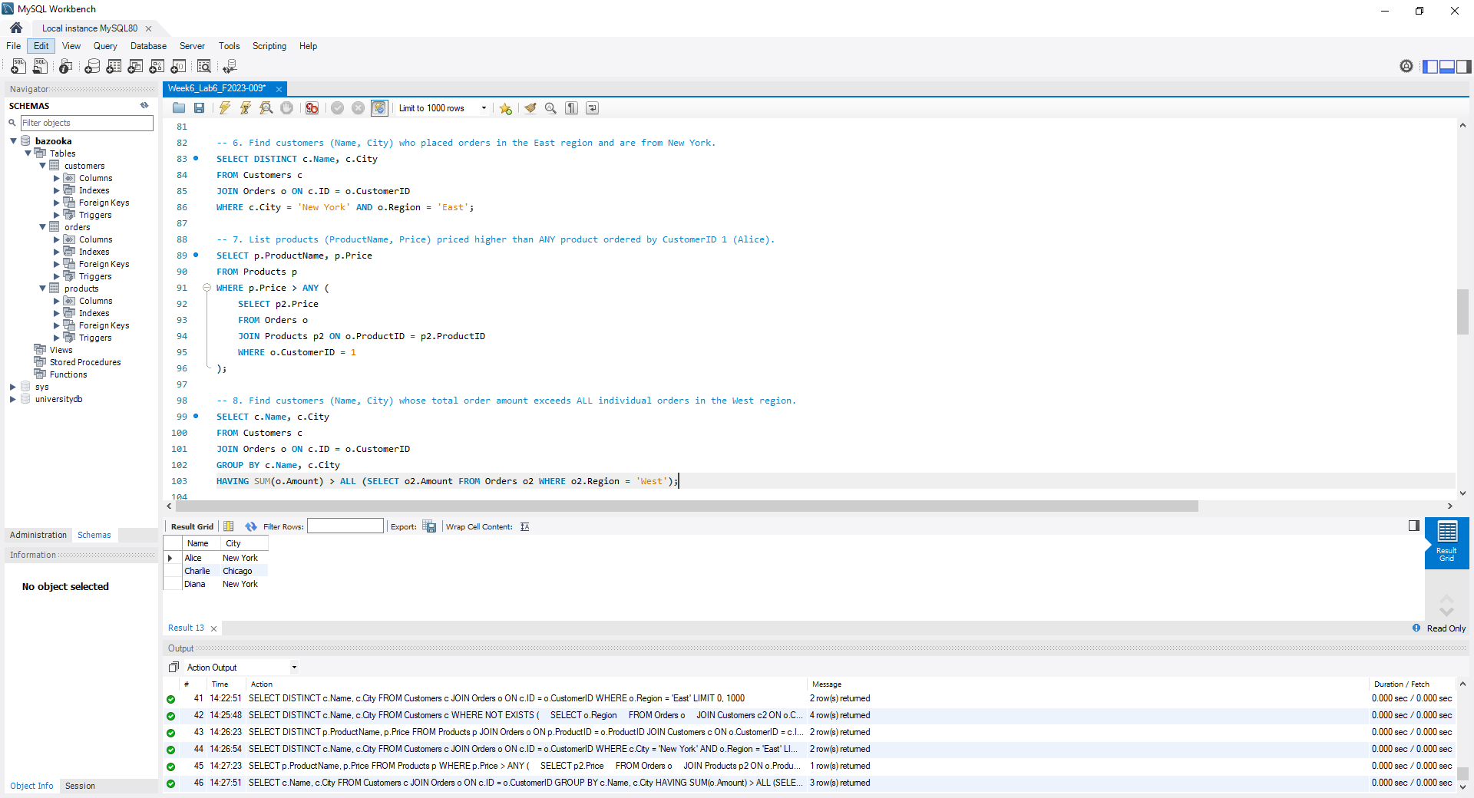

9. List customers (Name, City) who placed orders in all regions where their city’s customers have ordered.
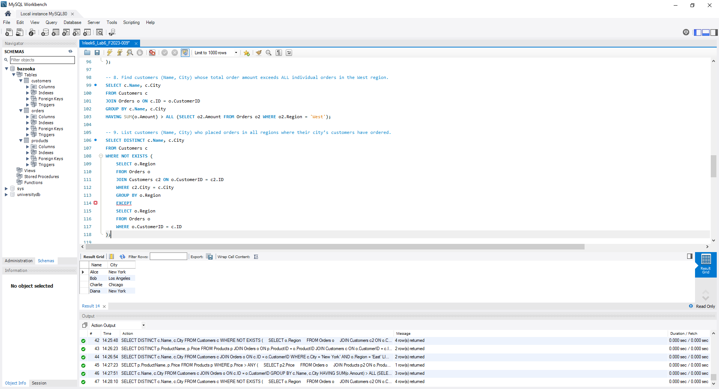
10. Show customers (Name, City) and their most expensive product purchased.
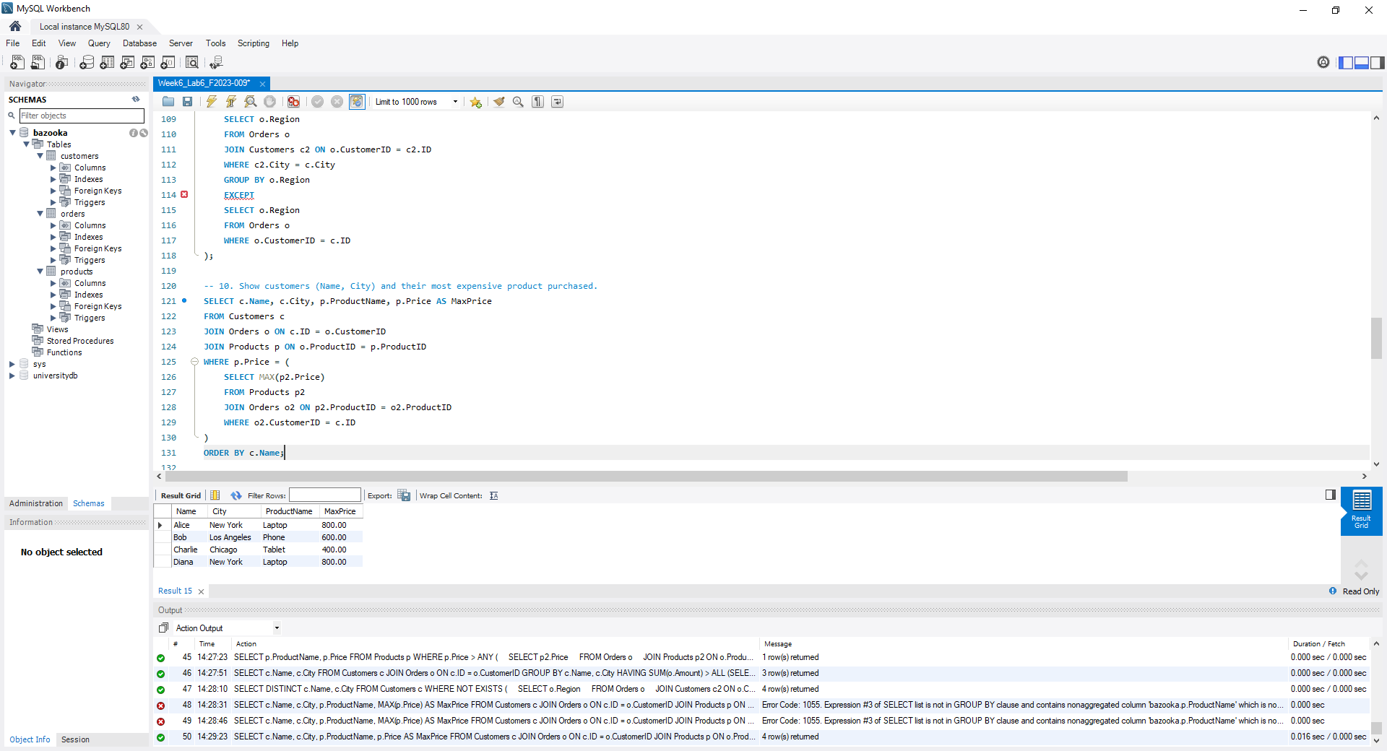

11. Find the product with the second-highest price (ProductName, Price).
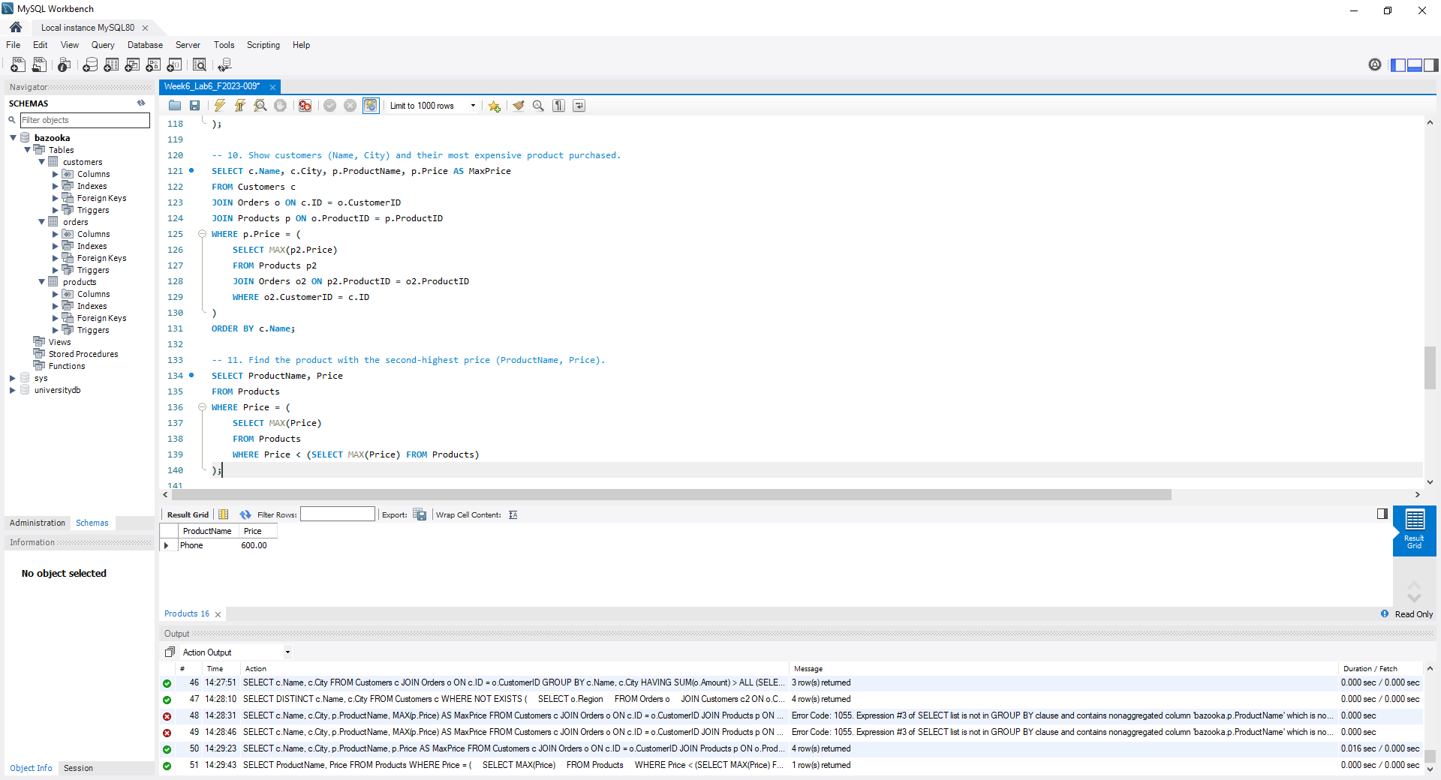
12. List customers (Name, City) whose total order amount is greater than the average total of their city.”
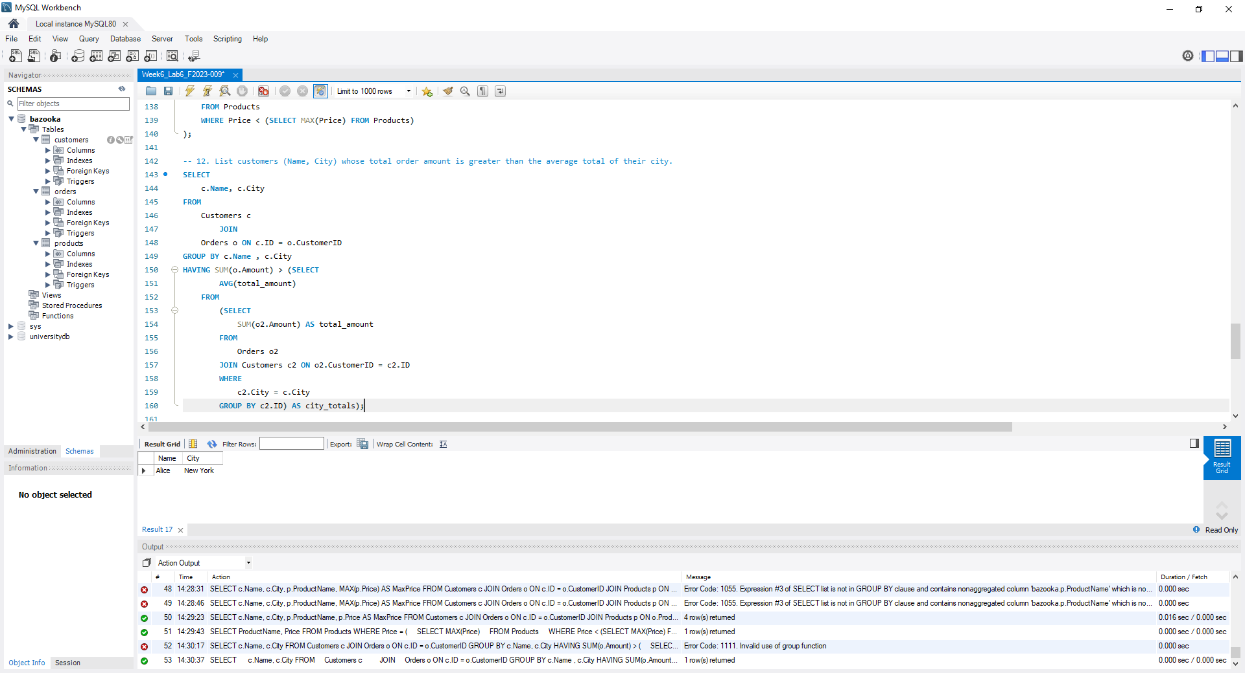

13. Find products (ProductName, Price) that were never ordered in the East region.
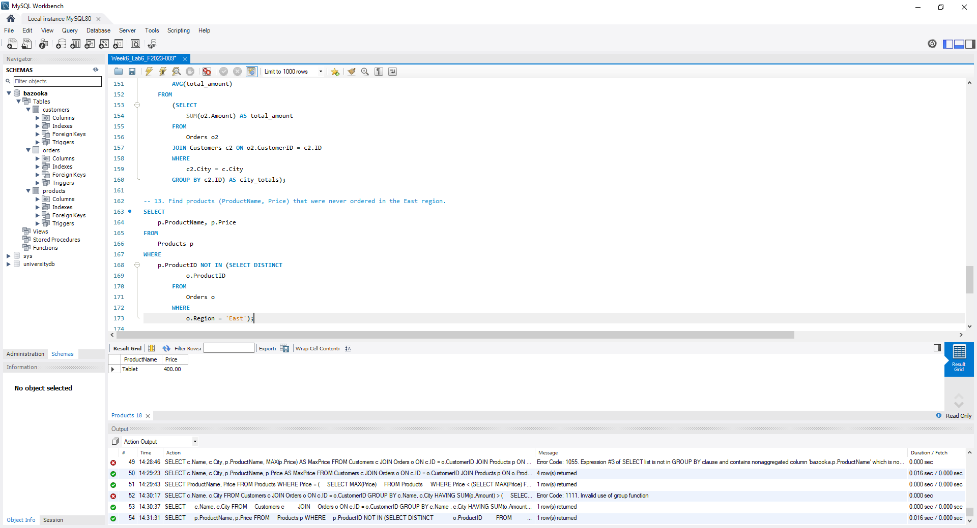
14. Find customers (Name, City) who have ordered every product available.
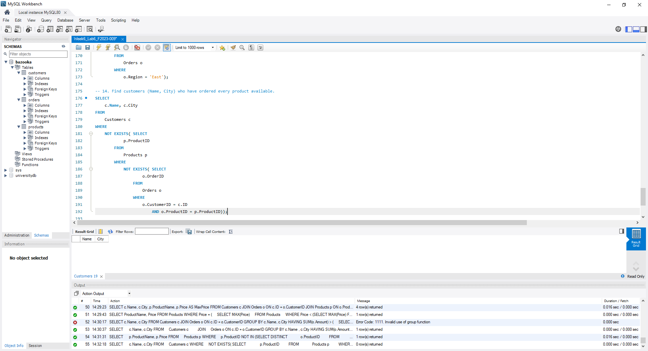

15. List each customer’s most recent order (Name, OrderID, Amount).
